Programming Project:

Team Information

Naomie Edward - 2242656 / Elsana Kanybek - 2236835

Project Description: Topic 3 - Library Management System

Build a system to manage a small library with books and members.

* You may have a list of books and users available in a text file.
* The app should display a list of all books, available books and borrowed books.
* The app should have features to checkout and check-in books.
* The app should generate a report for overdue books.
* When a book is checked out it status should be changed to not available.
  + The app should save the status to the file.
* Bonus features are adding new books and users to the system and saving them.

Development Approach

1. Understanding the problem:
   1. Figuring out the key points of the project
2. Formulating the problem:
   1. UML diagrams of classes with backing fields (planning)
3. Developing the application \ algorithm.
   1. Creating the UI on paper to have an idea
   2. Linking the classes and their relations to others
4. Implementing the application \algorithm:
   1. Start with WPF
   2. Creating the classes
   3. Connecting WPF to the classes
5. Testing:
   1. (BUG) Add/delete users or books was not updating after the program finished -> implemented an updating methods ->updates all files after operation
   2. (BUG) Blank and empty field entered -> throws an error and a message pop up
   3. (BUG) Sign up would crash after creation of a new user because of the password restrictions -> added the code in the .cs file to handle it.

***3 main pages:***

**First Page - Welcome Page:**

* User login, employees and clients login.
* New users can sign up to the system and their info is going to be saved.

**Second Page - Employee Window:**

* Add new employees
* Search books in the library:
  + See information on the book
  + Delete/add a book
* Search all clients:
  + See informations on the client
  + Delete/add a client
* Log out as employee

**Third Page - Client Window**

* See all the books in the library in the scroll bar
* Search a book by its name
* See all the information of the book on the side
  + Title, author, page number and status
* Borrow book if the status of the book is available
* See the list of all overdues books
* See the list of all borrowed books
* Could return a book on their account
* Log out as client

Appendix B: UML Class Diagram

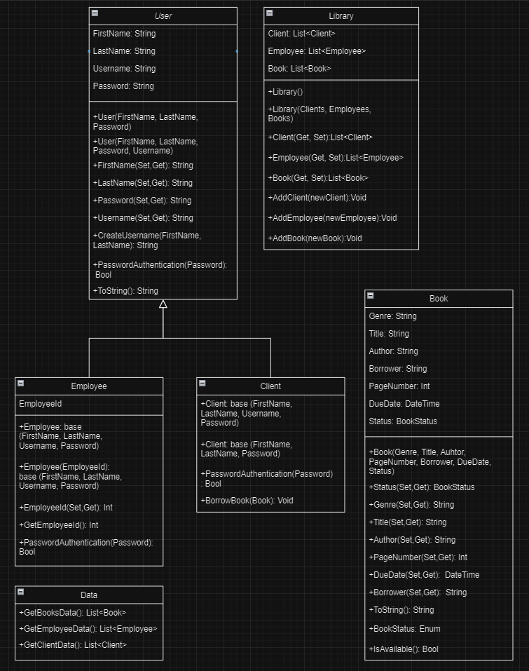

Contributions

| **Elsana** | **Naomie** |
| --- | --- |
| MainWindow.xaml | MainWindow.cs |
| ClientWindow.Xaml and .cs | EmployeeWindow.Xaml and .cs |
| Sub windows for client & employee windows  (both xaml and cs) | Sub windows for client & employee windows  (both xaml and cs) |
| Comments | Comments |
| Project Document | UML |

App Snapshots

This section includes snapshots of the final application showing different features. It could be a guideline to using the application. You may include snapshots of the app while being developed. Remember to add explanatory captions to the snapshots.

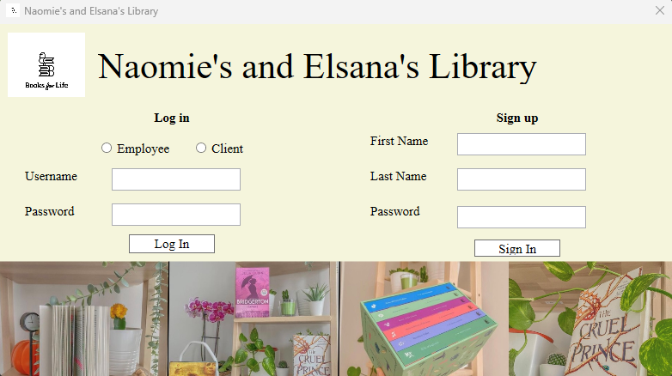

* User login, employees and clients login.
* New users can sign up to the system and their info is going to be saved.

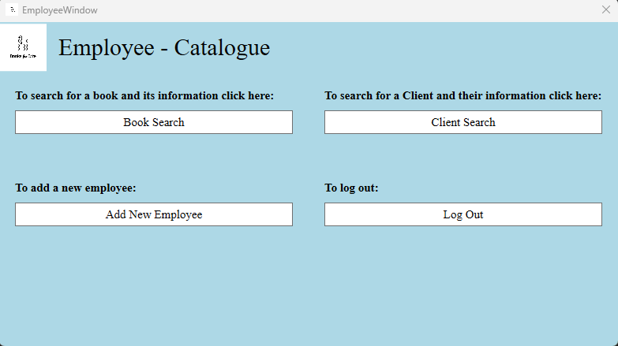

* Add new employees
* Search books in the library:
  + See information on the book
  + Delete/add a book
* Search all clients:
  + See informations on the client
  + Delete/add a client
* Log out as employee

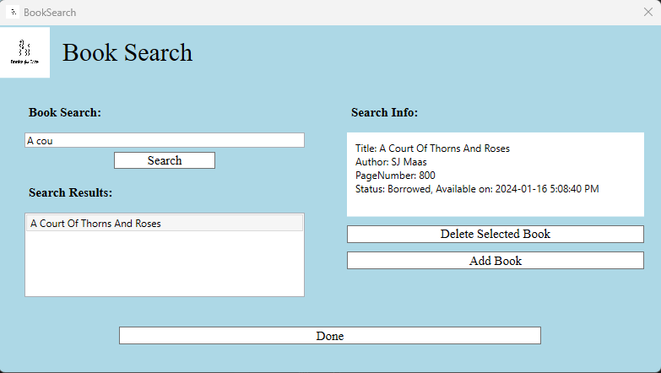

* Search books and see their information and if the book is borrowed.
* Can add and delete the book

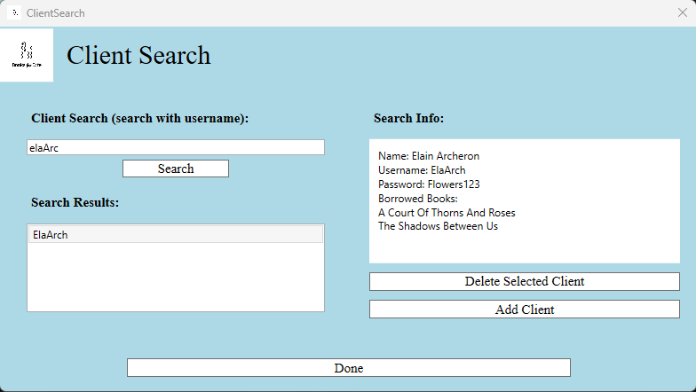

* Search for the client information and what books have they borrowed.
* Can add and delete the client

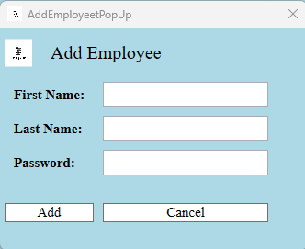

* Employee can add a new other employee

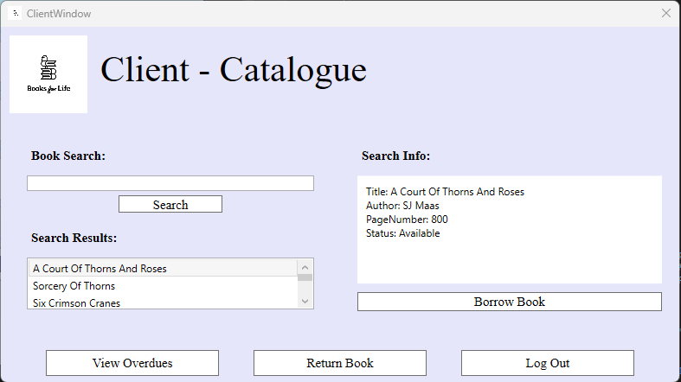

* See all the books in the library in the scroll bar
* Search a book by its name
* See all the information of the book on the side
  + Title, author, page number and status
* Borrow book if the status of the book is available
* See the list of all overdues books
* See the list of all borrowed books
* Could return a book on their account
* Log out as client

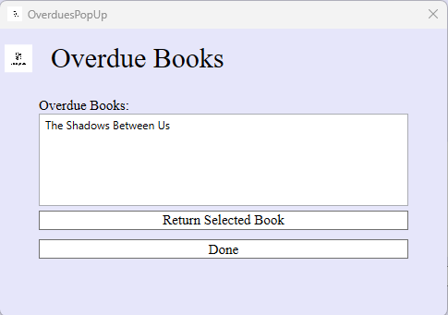

* See the list of all overdue books of the client
* Can return the book

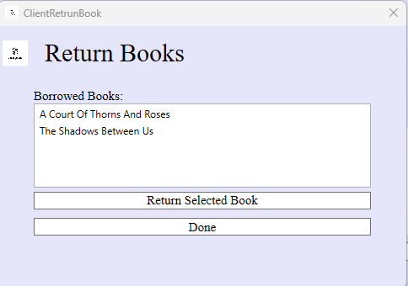

* See the list of all borrowed books of the client
* Can return the book

Future Work

Discuss features or improvement that can be added to application.

1. Employees could have access to modify the client information.
2. Clients could search books by authors and genres, not only titles.
3. Different types of client accounts, example a kid or adult account with different restrictions for the reading age and suggestions.